|  |
| --- |
| University of Waterloo – Software Engineering |
| The Waste Disposal Initiative |
| November 28th, 2013 |

http://www.engineering.uwaterloo.ca/images/foe-logo.gif

|  |
| --- |
|  |

Aditya Sridhar a3sridha 20539123

Ayush Bhagat a4bhagat 20522798

David Su dysu 20516776

Hanumanth Kumar Jayakumar hkjayaku 20527136

Pushpak Kumar p23kumar 20504564

Sahil Jain s44jain 20512777

Weilong Wu w62wu 20525183

May 11, 2013

Krzysztof Czarnecki, Professor

Electrical and Computer Engineering

University of Waterloo

Waterloo, Ontario

N2L 3G1

Dear Professor,

This report, entitled “GarBot”, has been prepared as a submission for the course Introduction to Software Engineering. The project is based upon the idea of developing an optimal solution for waste management that is cost-efficient, environmentally friendly and requires minimal human effort. The purpose of this report is to demonstrate the development process of the GarBot.

The team programmed a Parallax S2 Scribbler robot using the Python programming language and the Myro library. The robot autonomously isolates garbage and transfers it to its corresponding garbage bin. The movement of GarBot is controlled by obstacle and line sensors, whereas image processing is used to separate color-coded waste.

The project is consistent with software engineering standards and thoroughly follows engineering design principles. The team decided to use the incremental lifecycle model to most effectively carry out the development process. This was an ideal approach because the requirements of the project were known beforehand. The implementation and testing phases were carried out in increments. In doing so, a variety of software engineering activities such as planning, design, debugging, testing, and maintenance were used. We also used the Agile Software Process – thus providing us flexibility to change design goals and working code.

The team acknowledges Professor Krzysztof Czarnecki, for his assistance throughout the development process. We appreciate the help provided by all the Teaching Assistants. The team also confirms this report has not been previously submitted for academic credit at this or any other academic institution.

Sincerely,

Team 7

**Executive Summary**

This report summarizes the problem statement, the development of the solution, and the outcome of this project. Our project is based upon the idea of developing an optimal solution to manage waste.

This report exhibits the major aspects of the design process from an engineering perspective, as well as demonstrating the observations and results of this project. The report will analyze the problem specifications, provide the best solution, and demonstrate the development process of the solution.

The objective of this project is to design a robot that effectively disposes waste. It proposes a solution to the real-life problem of waste management. In order to simulate this on a small scale, the team has designed a robot that locates a cylindrical object of a specific colour and moves it to its respective box. There are cylinders with two different colours symbolizing different types of waste, and each of them is disposed into its corresponding bin.

A set of criteria is then made based on the problem specifications, with the emphasis placed on the robustness of the presented solution. The robot must be as reliable as possible, and be able to perform its duties with little to no maintenance.

We then analyzed these criteria, and came up with a viable design for the project. The results are stated against the defined constraints and how they are met. Conclusions are drawn regarding the problem and the proposed solution.

Furthermore, recommendations for improvement are made, with a clear outline for achieving these improvements.

# Table of Contents

Executive Summary ................................................................................................................ iii

List of Figures ......................................................................................................................... v

List of Tables ........................................................................................................................... vi

1 Problem Description ........................................................................................................... 1

2 Design Constraints and Criteria.......................................................................................... 1

2.1 Camera…………………………................................................................................. 1

2.2 Obstacle Sensors ......................................................................................................... 1

2.3 Bluetooth……………………………………………………………………………... 2

3 Analysis and Design .......................................................................................................... 2

3.1 Design Challenges ...................................................................................................... 2

3.2 Physical Design .......................................................................................................... 3

3.3 Basic Algorithm .......................................................................................................... 4

3.4 Software Outline……………………………………………………………………….7

3.5 Results……………………………………………………………………………......10

3.6 Conclusions…………………………………………………………………………..11

3.7 Recommendations for Improvement…………………………………………………11

References .............................................................................................................................. 12

**List of Figures**

**Figure 3-1.** Physical Appearance of Scribbler 2 Robot…………………………………………..3

**Figure 3-2.** Fluke Board…………………………………………………………………………..3

**Figure 3-3.** Garbot………………………………………………………………………………...4

**Figure 3-4.** Project Model………………………………………………………………………...4

**Figure 3-5.** Work Breakdown Structure………………………………………………………….6

**Figure 3-6.** Software Outline……………………………………………………………………..8

**Figure 3-7.** Gantt Chart…………………………………………………………………………...9

**Figure 3-8.** Apparatus and Results………………………………………………………………10

# List of Tables

**Table 3-1.** Project Timeline……………………………………………………………………..9

**1 Problem Description**

Waste management is a significant problem in today's rapidly developing world. In many urban areas, sidewalks are littered with garbage because humans do not dispose of it appropriately. In fact, over 75% of people surveyed admitted to littering in the last five years [1]. This apathy to separate different types of wastes is hazardous not only to the environment but also to humans. Furthermore, littering is a liability that costs over 11.5 billion dollars to manage [1].Therefore, a sustainable and cost-effective solution is required. The Waste Disposal Robot serves these needs. It is an inexpensive Scribbler S2 robot programmed to autonomously detect and dispose of garbage. It will reduce cost and human effort drastically without harming the environment.

**2 Design Constraints and Criteria**

We are isolating waste according to colour. However, in the real world, this method is not reliable for the following reasons:

**2.1 Camera**

One of the main constraints in this project is the camera on the fluke board. The function of the camera is to capture images of the view in front to locate the garbage. The program captures the image and reads the number of pixels that are within a set range of predetermined RGB values that represent garbage. Once the garbage is detected, the robot moves in its direction.­ Additionally, the camera is also used to locate the garbage bin. Therefore, the project is heavily dependent on the functionality of the camera. However, its inconsistency made it a constraint. The camera outputs different RGB values at different times with the same set of input, causing it to be unpredictable. This limits the ability of the robot to accurately detect objects. The camera is also heavily dependent on the lighting of the room. Specifically, even marginally lighter or darker conditions caused it to behave erratically. These problems with the camera put a constraint on the project.

**2.2 Obstacle Sensors**

The chopsticks that are attached to the back part of the robot act as an arm to move the garbage. The robot uses the obstacle sensors on the fluke board to detect whether the garbage is within a certain distance from the garbage. The robot then turns 180 degrees such that the back part of the robot faces the garbage and then moves forward. The infrared sensors on the back of the robot were supposed to detect when the robot is within a certain distance from the garbage. However the failure of the obstacle sensors to report consistent readings led to a change in the design. Instead of using the faulty sensors, the team decided to back into the garbage by a certain distance to ensure the garbage was successfully picked up into the arms of the robot. This change made the algorithm more susceptible to errors.

**2.3 Bluetooth**

The bluetooth provided to the team is unreliable. It did not connect to the computers in the WEEF during the initial part of the project. As a result, the team had to spend three days on trying to make the bluetooth connect to the computers, which significantly stalled the progress. Also the Myro software provided did not work on computers with Windows 8 or Mac OS X. As a result of these two matters mentioned above a considerable amount of time and effort were wasted.

**3 Analysis and Design**

### 3.1 Design Challenges

The Waste Disposal Robot will be programmed to autonomously detect garbage, sort it according to its type, and dispose of it in the appropriate container. There will be three types of garbage: biodegradable waste, non-biodegradable waste, and recycling, as well as a corresponding container for each. The robot will need to reliably collect all garbage in a given area. Using the camera, it will accurately differentiate between different types of garbage as well as identify and avoid obstacles with the help of the infrared sensor. The robot will need to detect when it is in contact with a piece of garbage and move it, using an arm, towards the appropriate container without picking up a different type of garbage. Lastly, the robot will also clear the given area of waste in the most time-efficient manner possible.

# 3.2 Physical Design

The physical design will have 3 modules, the robot, the fluke card, and garbage holding apparatus. The robot we will be using is a Scribbler 2, given to us for the purpose of the project:

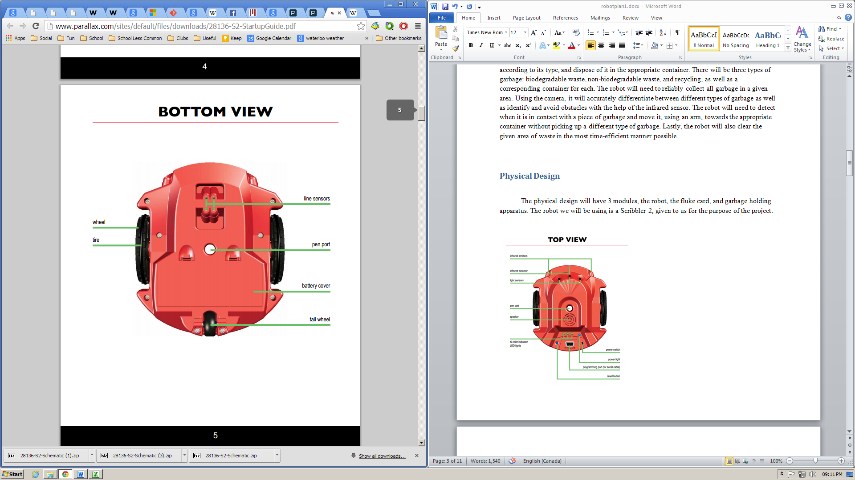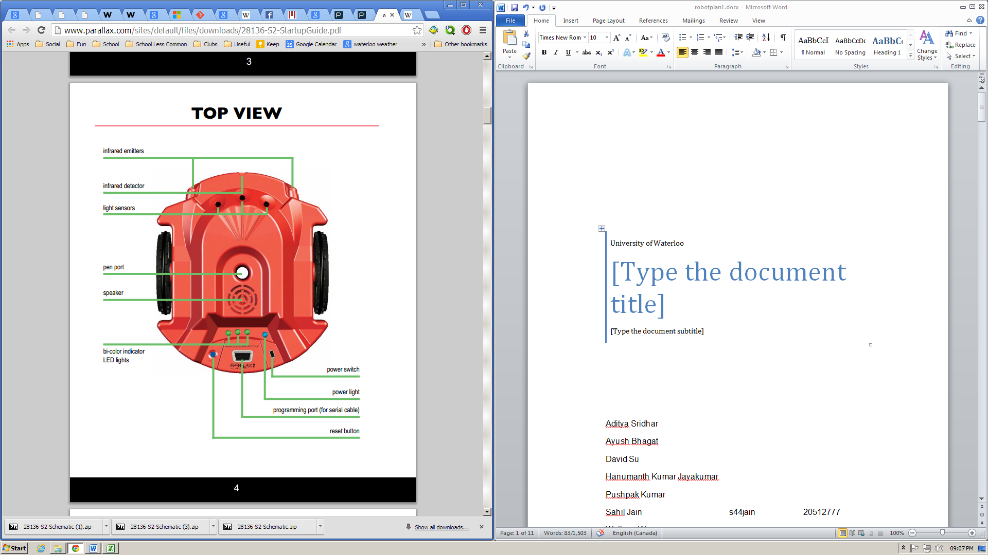

F

**Figure 3-1**. Physical Appearance of Scribbler 2 Robot

The fluke card will contain the camera and obstacle sensors:

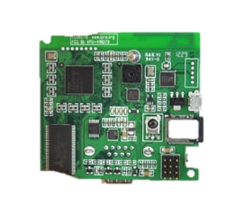

Camera

Infrared Obstacle Sensors

Serial Port

**Figure 3-2.** Fluke Board

The garbage holding apparatus:

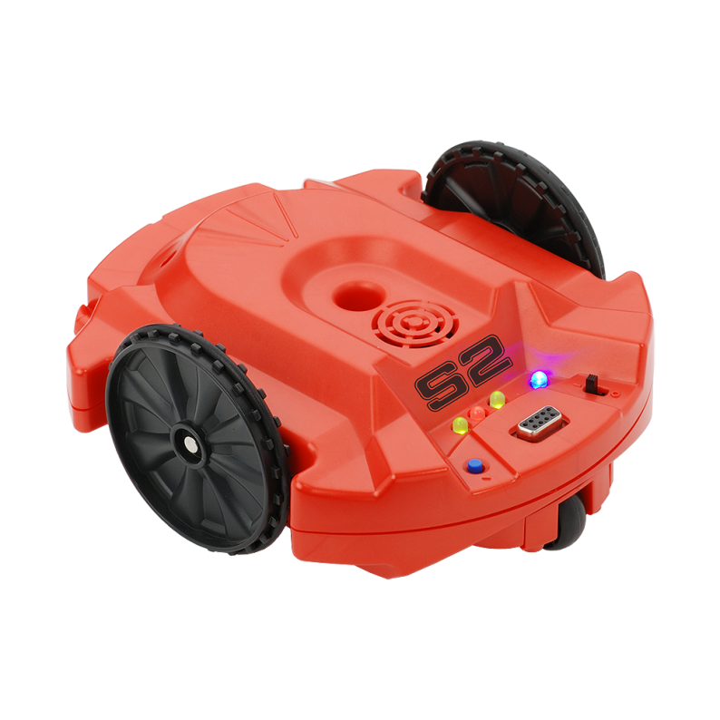

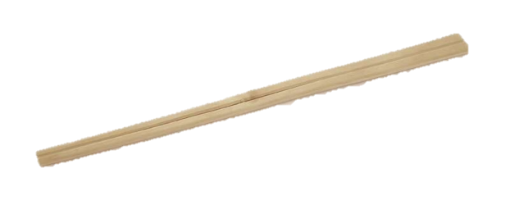

Tape

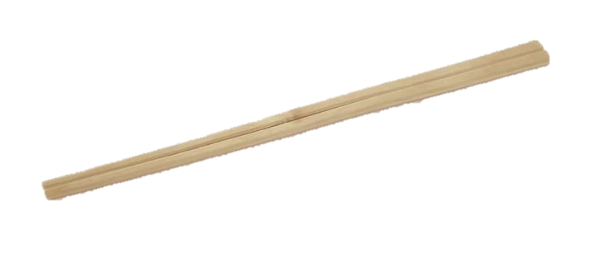

Arms

**Figure 3-3.** Garbot

**3.3 Basic Algorithm**

Garbage Bin

Robot

Garbage

**Figure 3-4.** Project Model

initialFind(colours)

1. Keeps turning until it finds the colour of one of the garbage
2. Returns the colour of that piece of garbage

find(colour)

1. Given a colour, keeps turning left
2. When the colour is found, adjust the robot until the garbage is centered on screen
3. Returns

moveToGarbage()

1. Keeps moving forward until either the obstacle sensor reading is sufficiently large, or number of pixels on the screen of the garbage's colour is sufficiently high.
2. Returns

putGarbageInBin()

1. Centers the robot in the direction of the garbage bin
2. Moves toward the garbage bin until the line sensors detected that the robot has entered the garbage bin
3. If a certain amount of time has been reached, and the robot has not yet reached the garbage bin, the robot will seek the garbage bin again.
4. Returns when the garbage has been successfully placed in the garbage bin.

**Figure 3-5**.Work Breakdown Structure

**The Waste Disposal Initiative**

***Requirements and Specifications***

***Design***

***Implementation***

***Testing***

***Deployment***

Problem definition

Initial research

Project proposal

Project plan

Fixing architectural model

Coding individual modules

Combining modules

Unit testing

Product testing

Preparation for release

**3.4 Software Outline**

# Constants.py

This module holds all the constants in our program. These constants consist of numerical values which are used throughout our code. For example, there are the speeds of the motors, the turn ratios, and the sensitivities of the camera and the obstacle sensors.

# FindColour.py

This file contains our image recognition module. We decided not to use the colour detection code built into Myro, as we felt that it did not fit the level of accuracy needed to successfully complete this project.

# IsObstacleMet.py

This module contains the obstacle detection class. This class contains compensatory code used to make up for inadequacies in the obstacle sensor readings. To overcome this problem, we take multiple sensor readings in quick succession in order to filter out individual inaccuracies, assuming that the sensor readings are accurate the majority of the time.

# Main.py

This file contains the mainline logic of our project. An abundance of helper functions made this program more human readable. This function dictated the logical flow of the program, and implements the algorithm seen on the previous page.

**Figure 3-6.** Software Outline

|  |  |  |  |
| --- | --- | --- | --- |
| **Tasks** | **Duration (days)** | **Start Date** | **End Date** |
| *Requirements and Specifications* |  |  |  |
| Problem definition | 3 | Sep 19 | Sep 22 |
| Initial research | 4 | Sep 23 | Sep 27 |
| Project proposal | 4 | Sep 28 | Oct 2 |
| *Design* |  |  |  |
| Project plan | 5 | Oct 3 | Oct 8 |
| Fixing architectural design | 3 | Oct 9 | Oct 12 |
| *Implementation* |  |  |  |
| Coding individual modules | 21 | Oct 13 | Nov 3 |
| Combining modules | 19 | Nov 5 | Nov 24 |
| *Testing* |  |  |  |
| Unit testing | 20 | Oct 15 | Nov 4 |
| Product testing | 18 | Nov 6 | Nov 24 |
| *Deployment* |  |  |  |
| Preparation for release | 2 | Nov 25 | Nov 27 |

# Table 3-1. Project Timeline

# Figure 3-7. Gantt Chart

**3.5 Results**

Our robot has one main function, to move and sort pieces of garbage based on colour. Out of 25 trials, our robot was successful 21 times. Out of the 4 failures, 3 of them were caused by the garbage slipping out of the robot arms. The other failure was caused by a visual processing error. Our robot was more successful at sorting garbage that was closer to the robot, due to limitations on the resolution of the camera. We found that the battery life of the robot allowed it to run for 5 hours non-stop. We also found that garbage of bright sharp colour was easier to sort than garbage of a dull colour. These results will aid us in improving the project for real-world use.

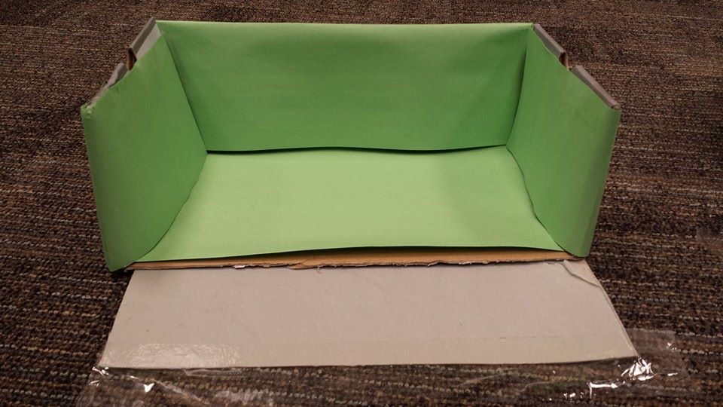 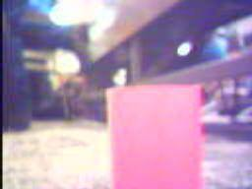Garbage bins Image of garbage taken by GarBot

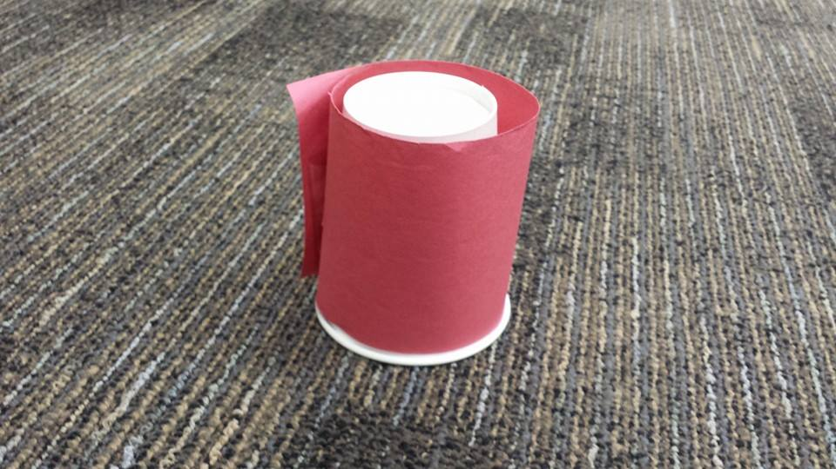 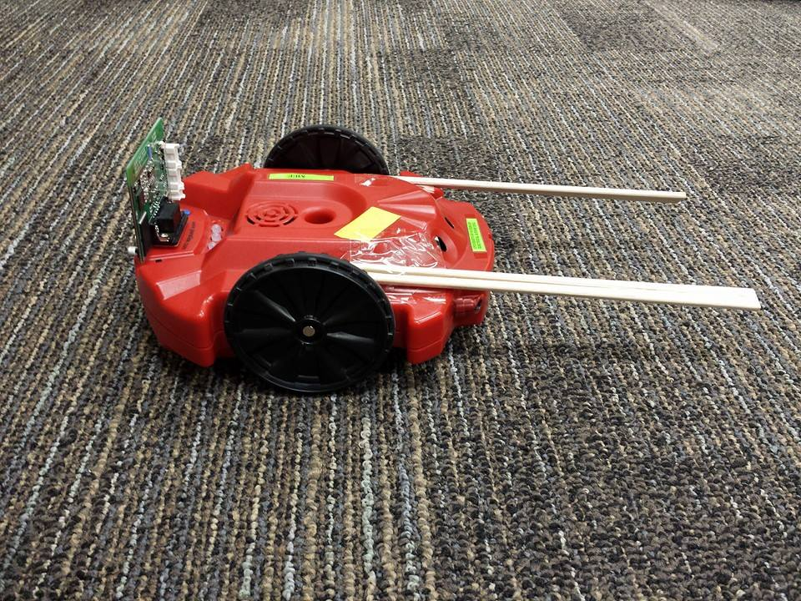 Garbage The GarBot

**Figure 3-8.** Apparatus and Results

# 3.6 Conclusions

From the results, we can assume that the failure rate of the robot is 16%. Given the timeframe for this project, we think that this is a reasonably low failure rate. The low resolution of the Scribbler 2's camera was the root of most failures. This low resolution has put a limitation on the distance that the garbage can be placed, thus making the robot efficient only in a certain radius. Because of the low quality camera, the robot can only differentiate garbage that is very bright in colour. In the real world, garbage is very dull in colour and can be camouflaged by its background. This problem can be avoided by using an ultrasonic sensor in conjunction with the camera to detect shapes and distances of the garbage from far away. Additionally, the mechanical design of the robot had the flaw of allowing the garbage to slip out during turning. The conclusions we’ve drawn from the results will help us improve the project for the future.

# 3.7 Recommendations for Improvement

This project could have been improved in many ways. Firstly, the robot is slow, and takes a lot of time to pick up each piece of garbage. In the real world, there are many articles of garbage, and the waste disposal process needs to be fast enough to not become a nuisance to humans. Another way we could improve the project is to equip more accurate sensors on the robot. We found that the infrared distance sensors on the robot were highly inaccurate, and as many as 10 readings had to be taken to obtain a reasonable response. Having a camera on both the front and the back of the robot would greatly also improve the speed and accuracy of the task as well. This can be achieved by using a robot other than the Scribbler 2.

While seeking the garbage, the GarBot could rotate more quickly until it detects the garbage, when it slows down and adjusts with finer movements until it is facing the garbage directly. The position of notable objects could also be recorded during the initial turning phase. Furthermore, the current garbage collecting apparatus is made of two parallel chopsticks. The garbage fits into the chopsticks and slides along the ground with the robot. Instead of sliding the garbage along the ground, using servo motors, we could lift the garbage up, and place it in a receptacle on top of the robot. This can be achieved by using a robot other than the Scribbler 2 (for example, the Lego NXT). These improvements together will significantly improve the projects efficiency, and create a viable path to real world application.

**References**

[1] "Littering Statistics." Statistic Brain 2013 [online]

http://www.statisticbrain.com/littering-statistics (Accessed: 2 Oct 2013).

[2] “Myro Installation Manual” [online]

http://wiki.roboteducation.org/Myro_Installation_Manual (Accessed: 15 Nov 2013).

[3] “Scribbler 2 Installation Guide” [online]

http://gsdlab.org/se101f13wiki/index.php?title=Scribbler_2_Installation_guide (Accessed: 15 Nov 2013)